**CRM APPLICAION FOR JEWEL MANAGEMENT**

**College Name:TIRUPPUR KUMARAN COLLAGE FOR**

**WOMEN**

**College Code: bru3j**

**TEAM ID:**

**NM2025MID28437**

**TEAM MEMBERS:**

**Team Leader Name: Preethi S**

**Email:** [**preethi5chitra@gmail.com**](mailto:preethi5chitra@gmail.com)

**Team Member1: Sivasankari S**

**Email:** [**sivasankarisudhagar@gmail.com**](mailto:sivasankarisudhagar@gmail.com)

**Team Member2: Hemadevi M**

**Email:** [**hemamurugan147@gmail.com**](mailto:hemamurugan147@gmail.com)

**Team Member3: Nithyasri S**

**Email:** [nithyasrinithyasri742@gmail.com](mailto:nithyasrinithyasri742@gmail.com)

INTRODUCTION

## 1.1 Project overview

The jewelry development projects aim to build a custom salesforce CRM solution for a jewelry retail and wholesale business. The system is designed to manage customer relationship, streamline sales operation, track inventory, and improve overall business efficiency.

## 1.2 Purpose

It works digitally transform the jewelry business by providing a centralized, intelligent, and customer-focused CRM platform.

DEVELOPMENT PHASE

Create developer account:

By using this URL - <https://developer.salesforce.com/signup> 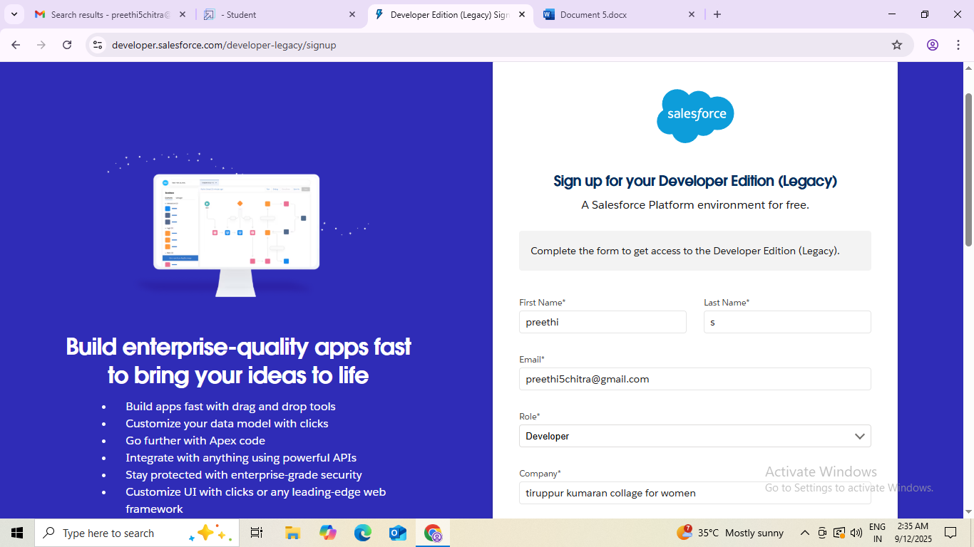

Creating custom objects: jewel customer, price, item, customer order

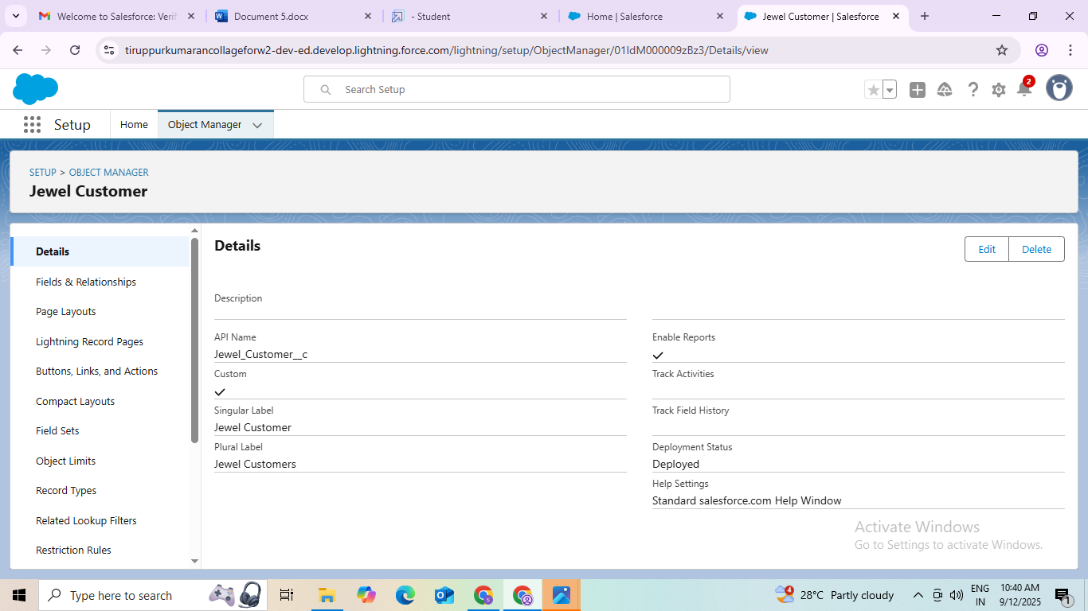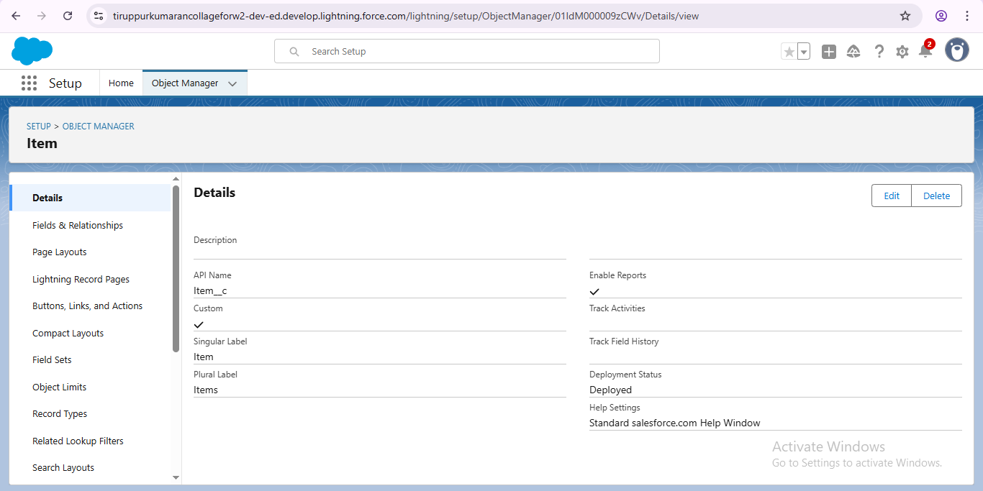

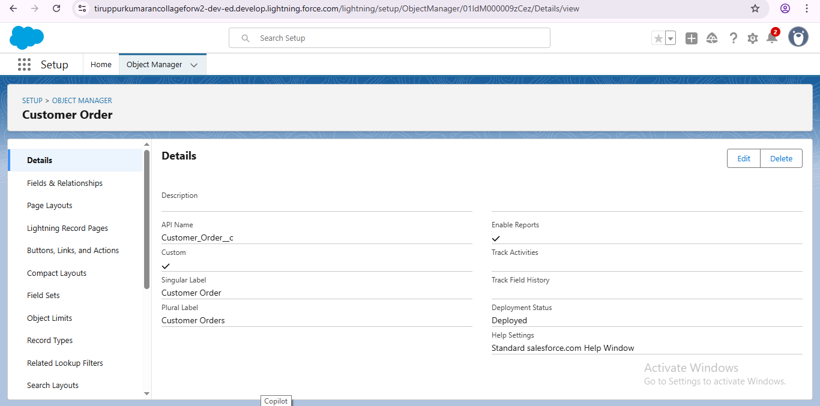 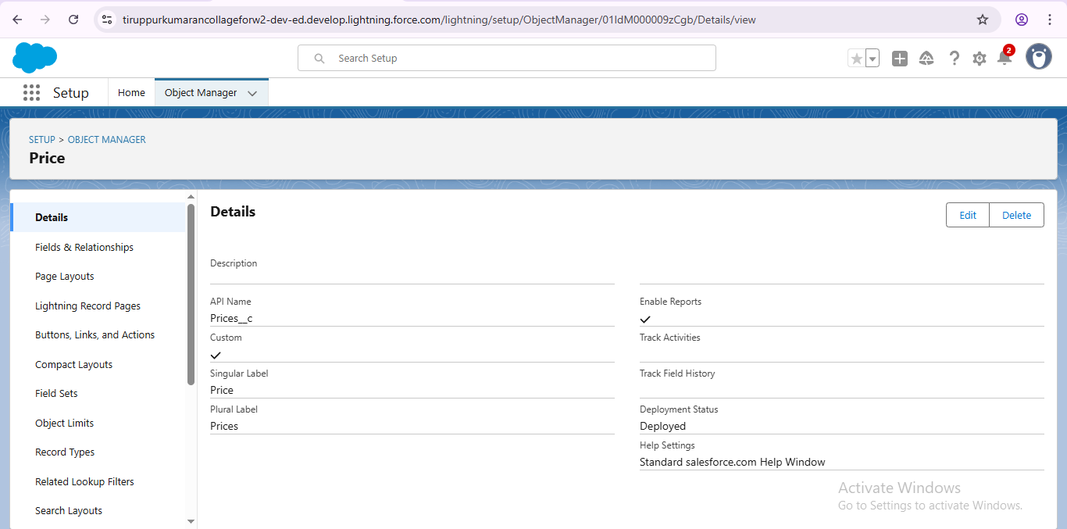configure fields and relationship

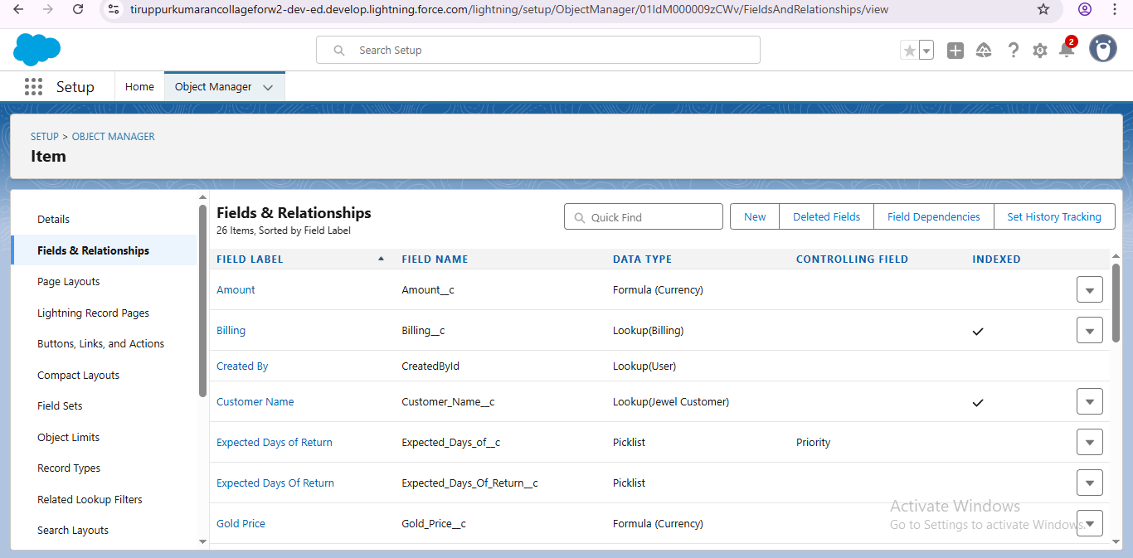

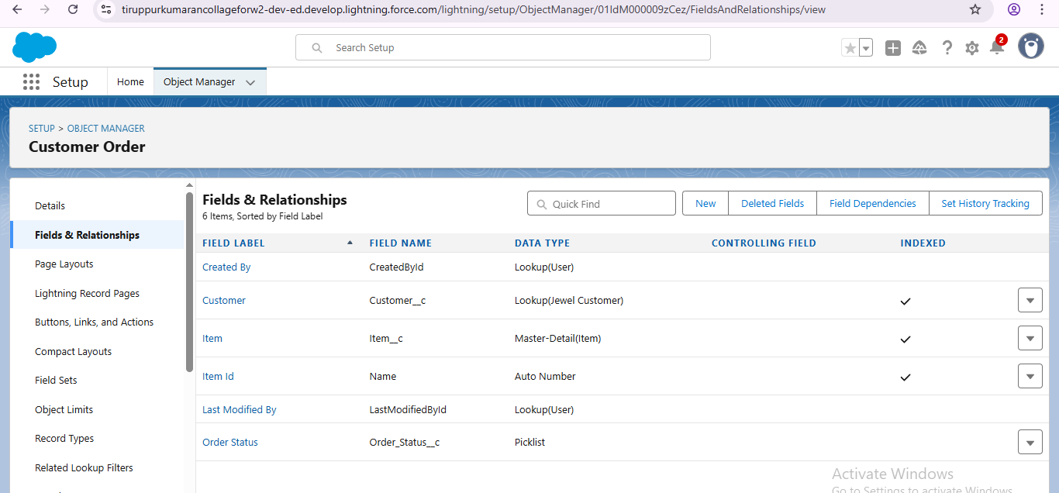

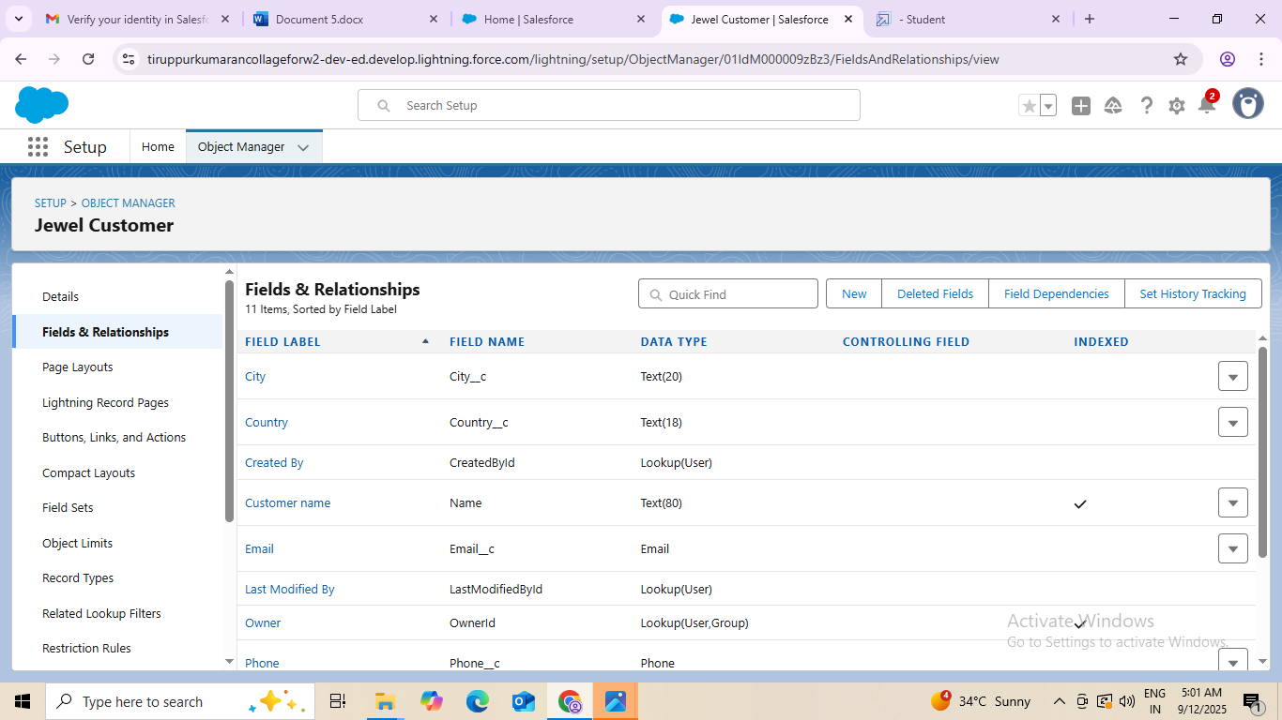

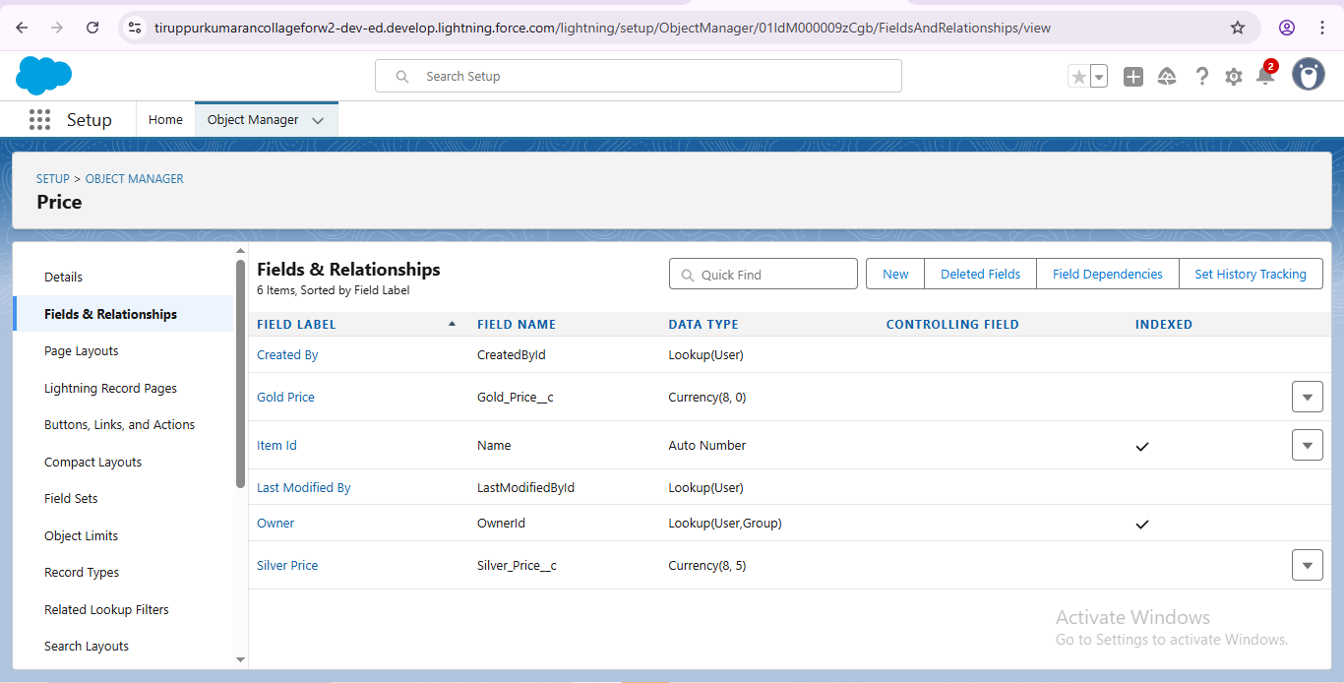

Developed lightning app with relevant tabs

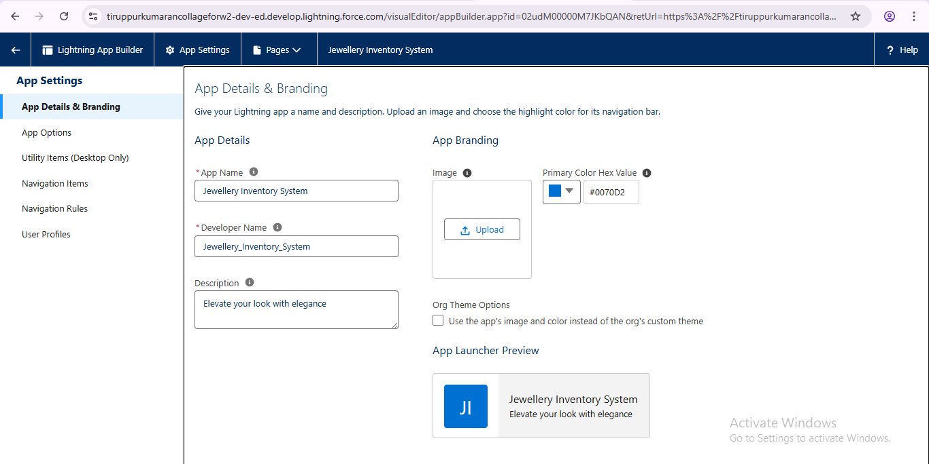

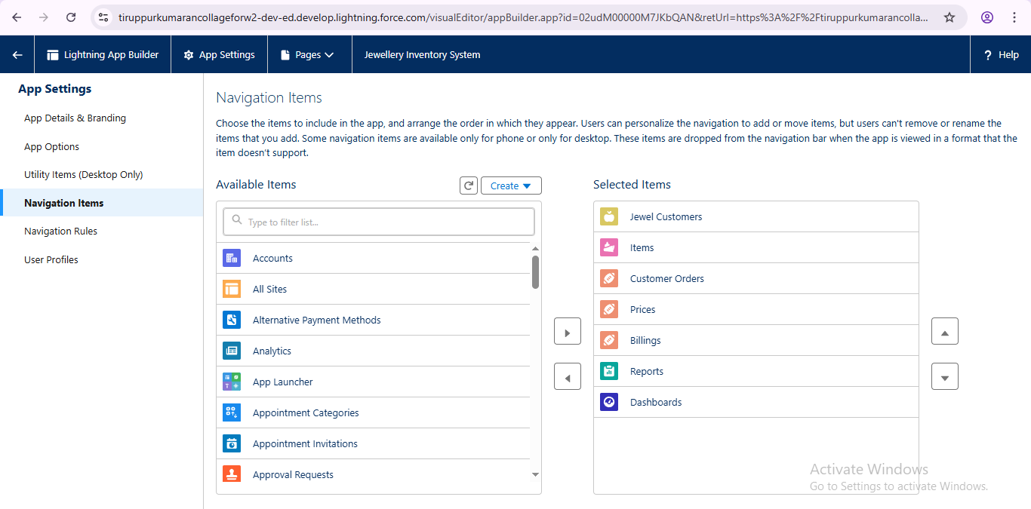

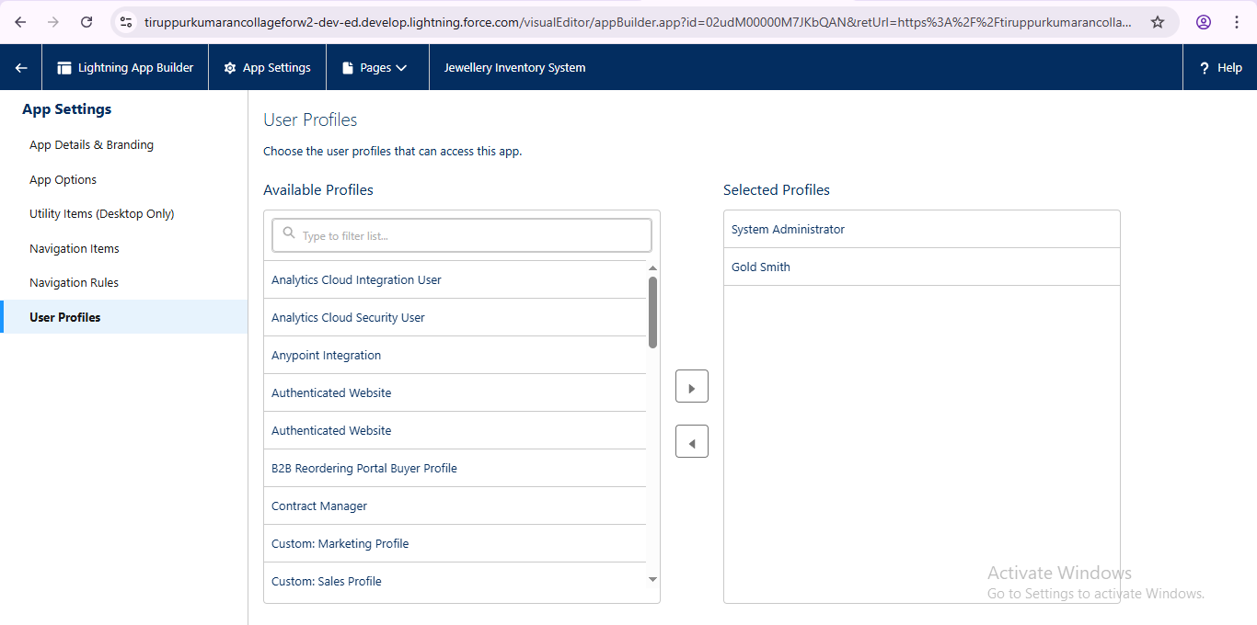

Creating custom tabs

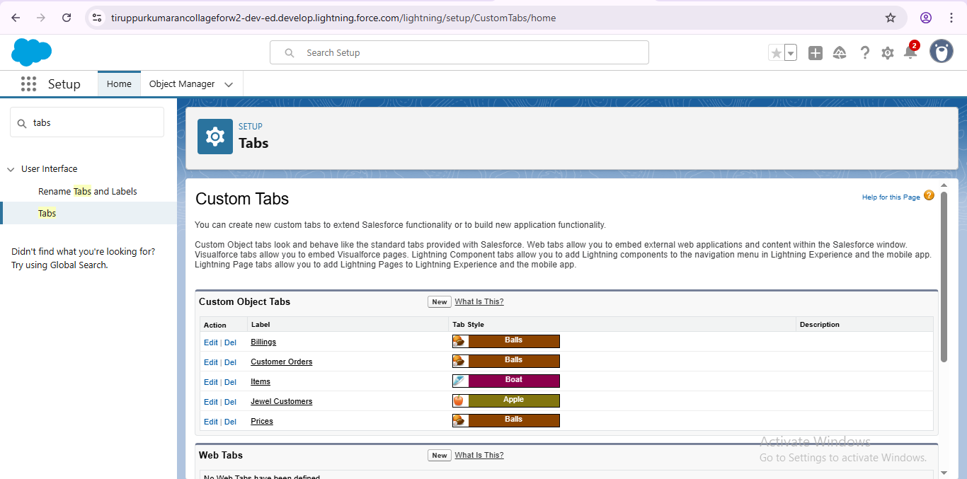

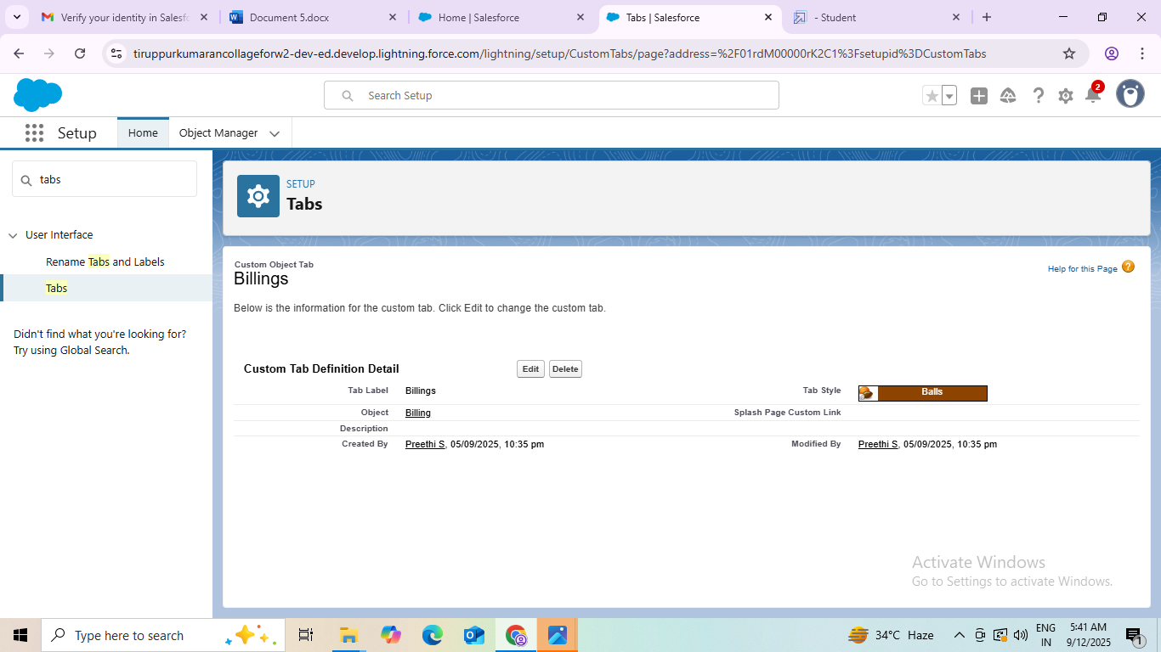

Creating fields (lookup relationship, master-detail relationship, text, phone, email, number, picklist, currency, formula)

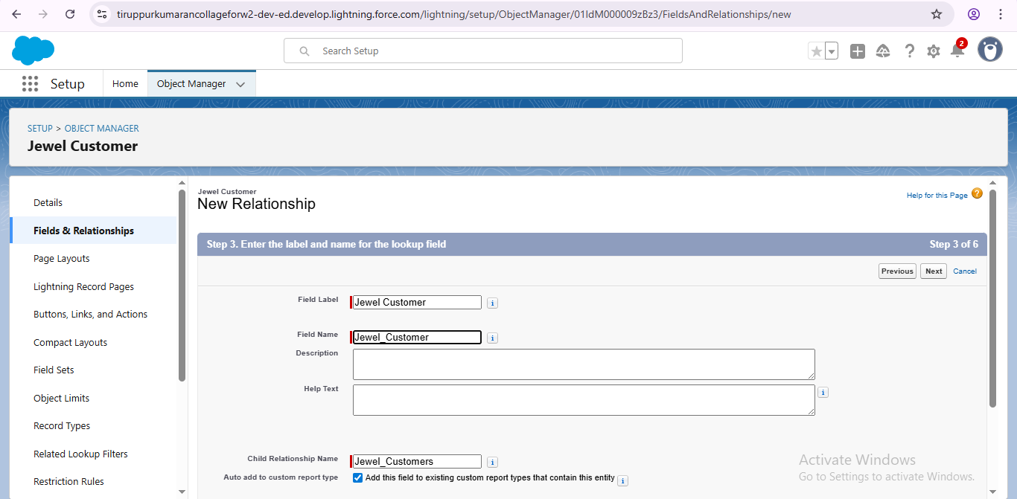

Creating field dependencies

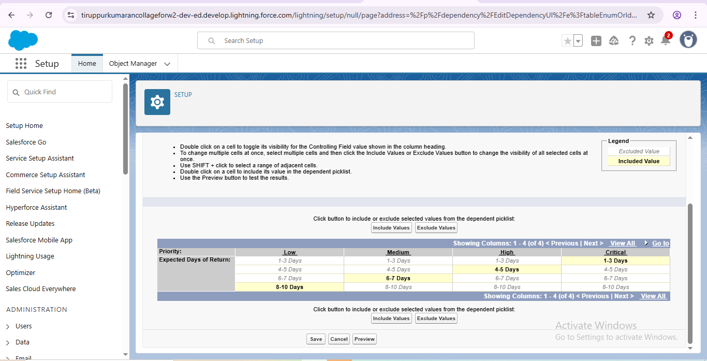

Creating validation rules

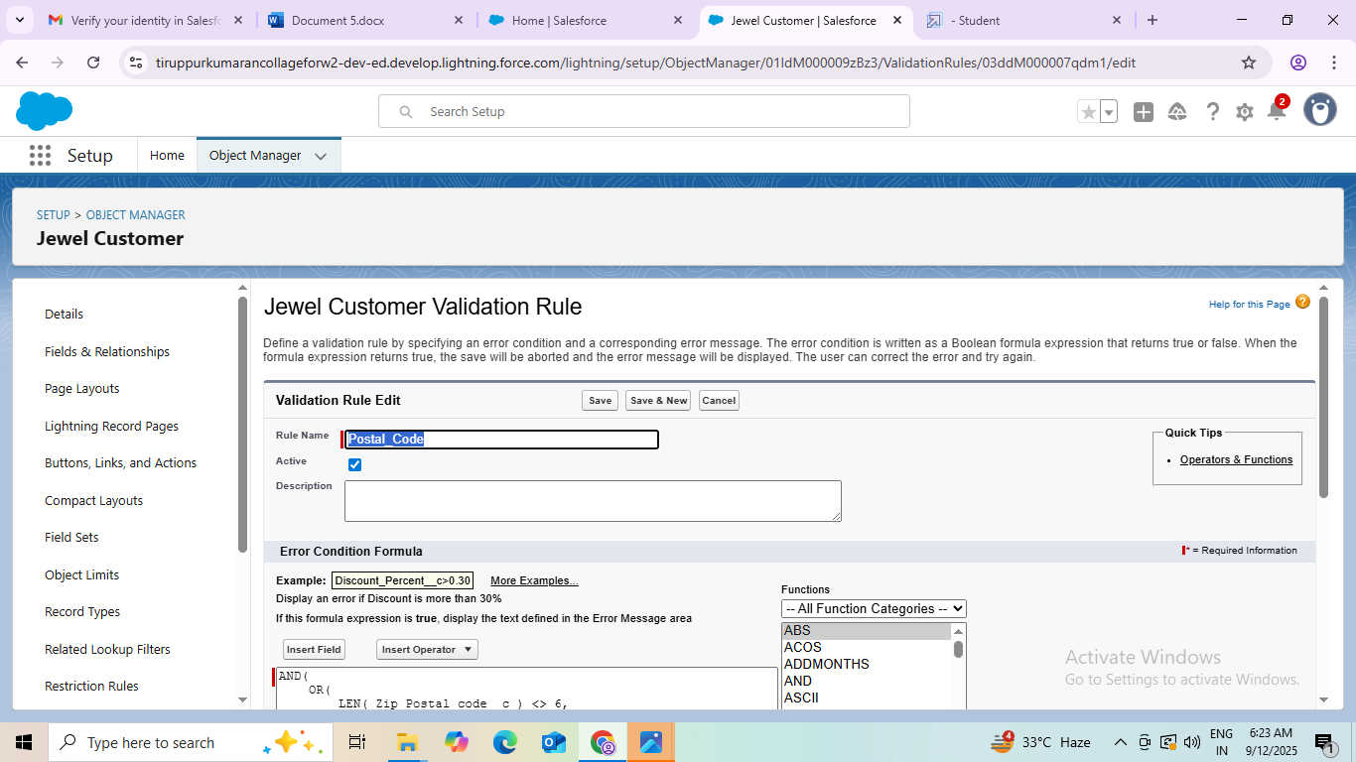

gold smith profile and profile creation

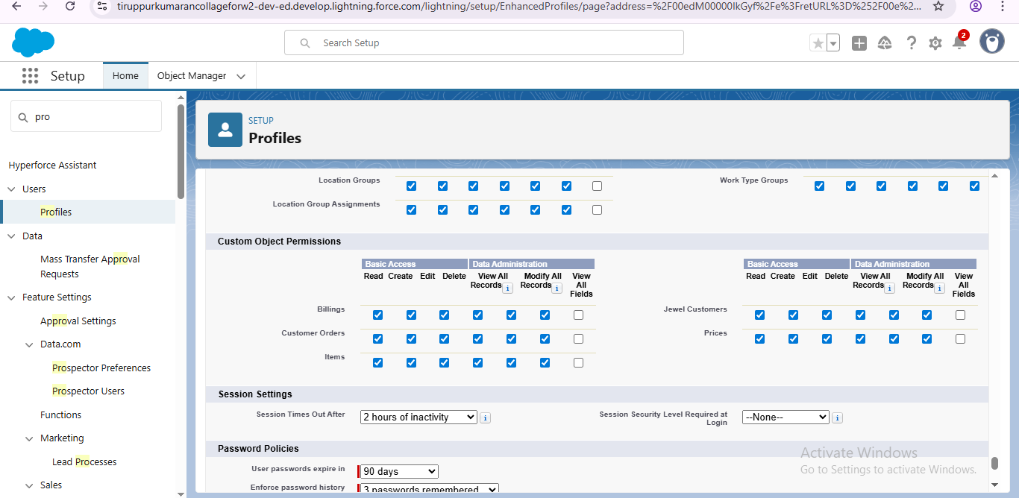

Creating role

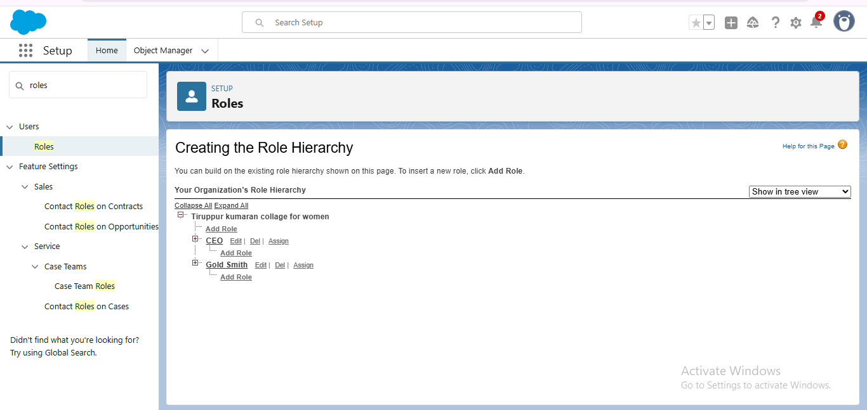

Users in field

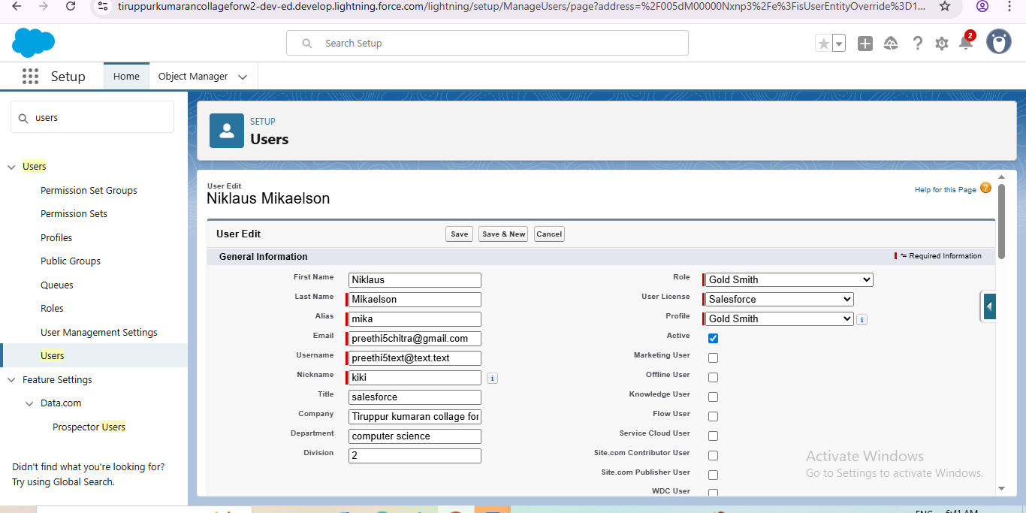

Defining the page layouts

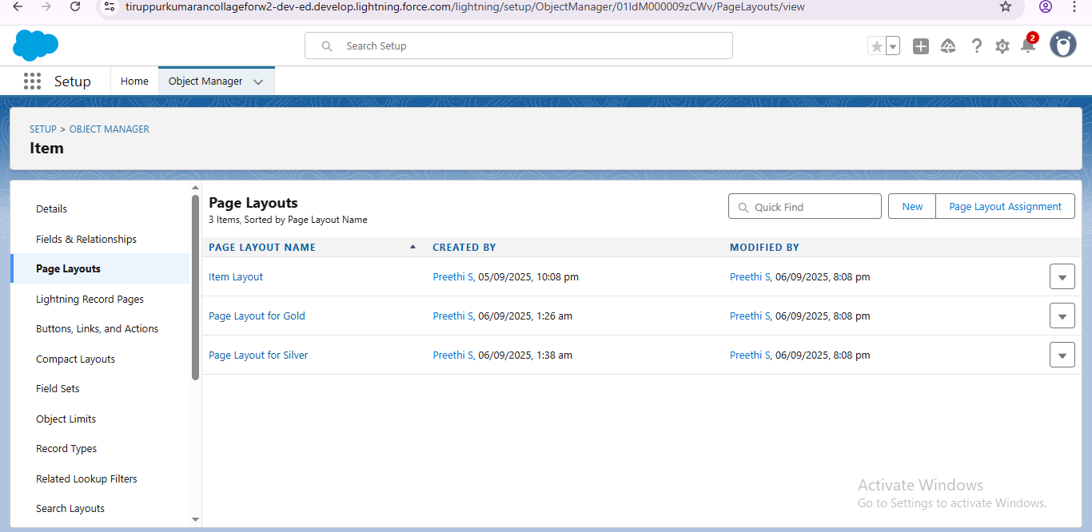

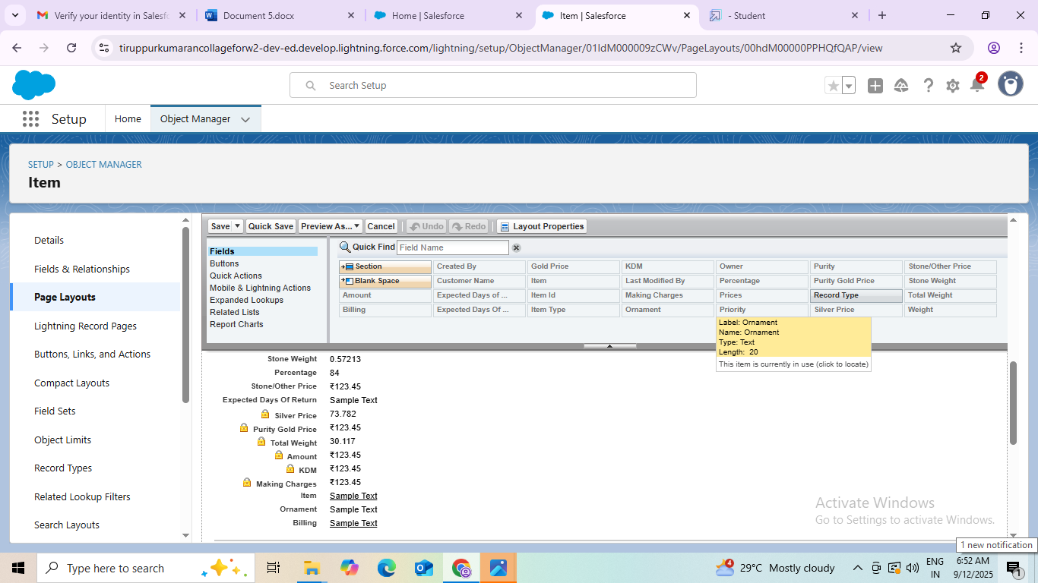

Creating record pages

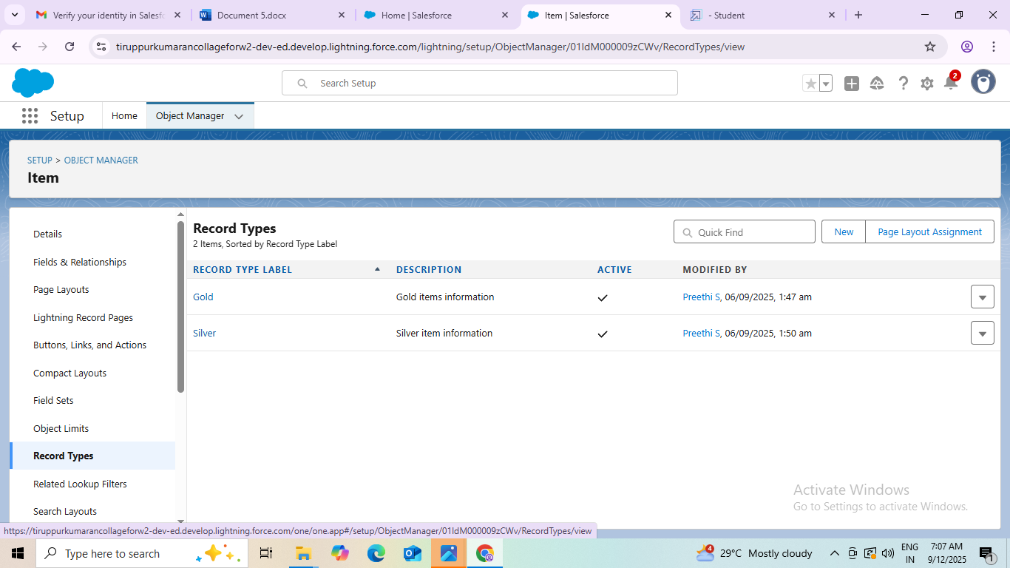

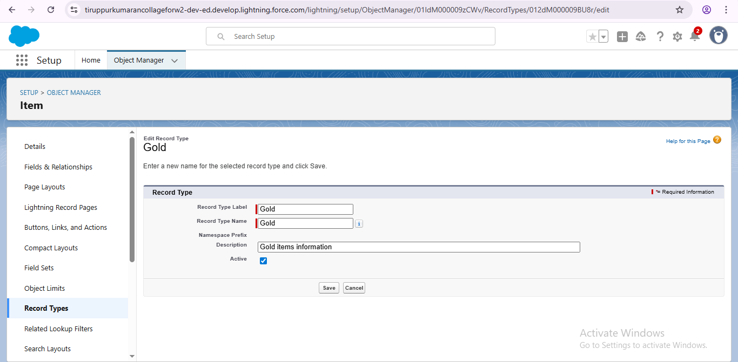

Permission set

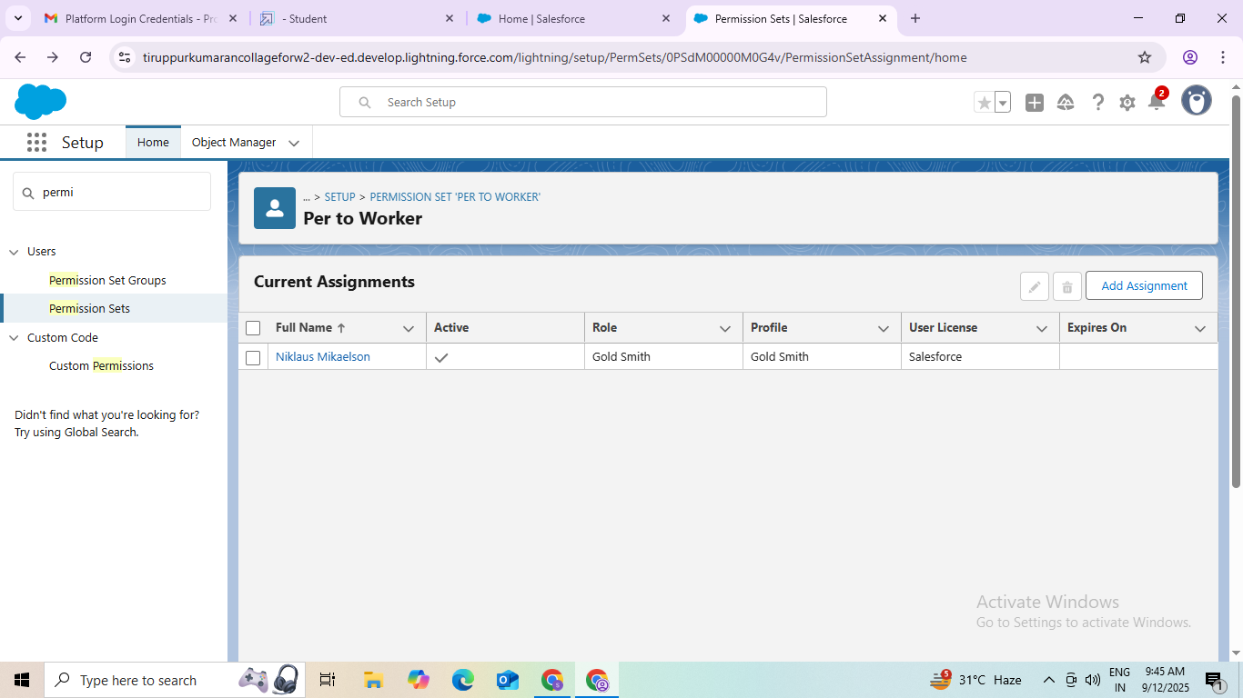

Creating triggers in apex

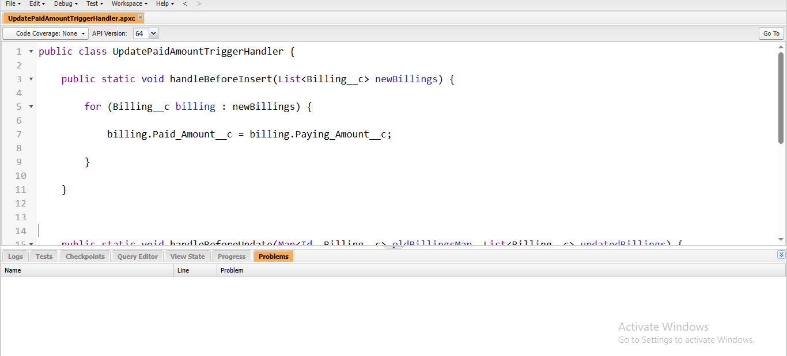

Insert reports

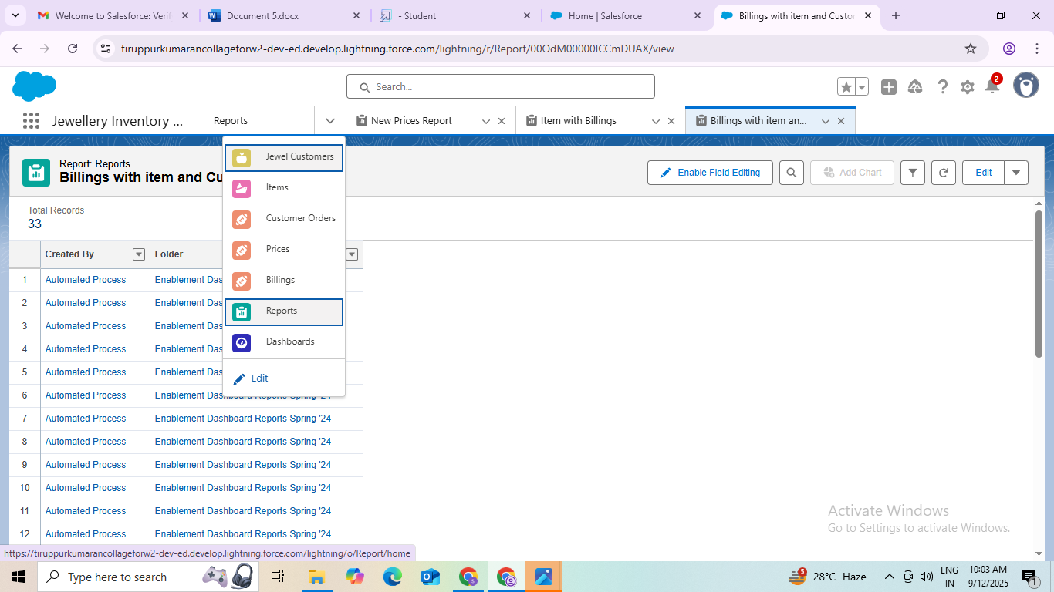

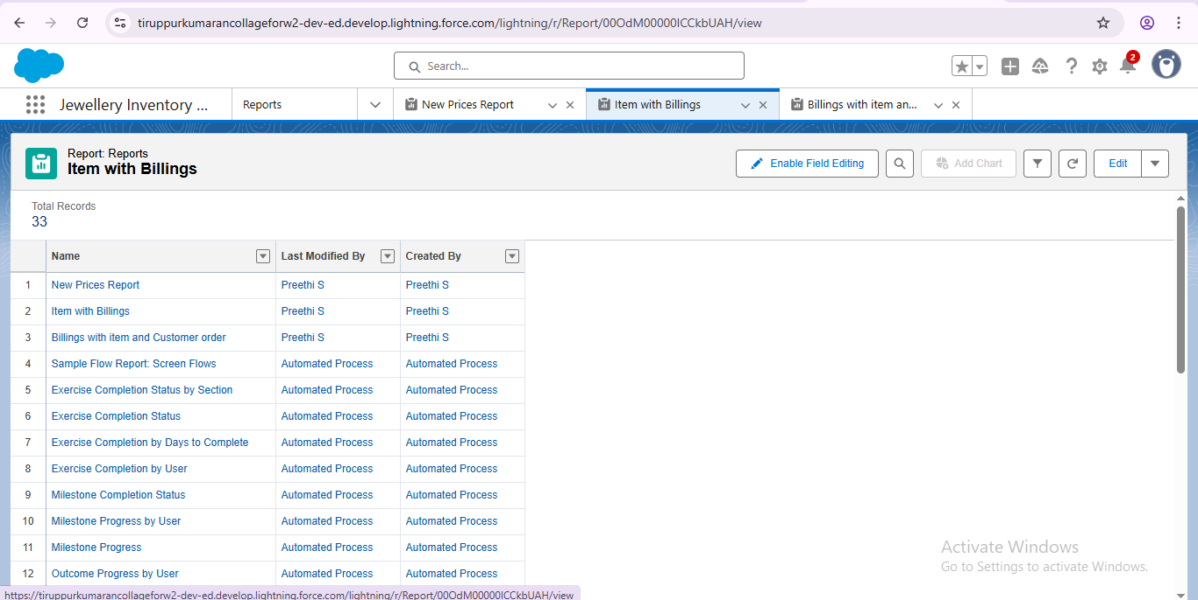

Creating dashboards



Create flows

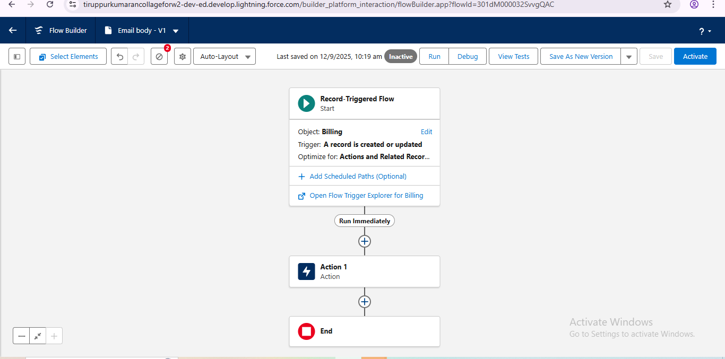

# Conclusion

The CRM jewelry management system plays a vital role in enhancing customers relationship and improving overall efficiency in the jewelry industry.

## APPENDEX

SOURCE CODE: Provided in apex class and triggers

## UpdatePaidAmountTriggerHandler:

public class UpdatePaidAmountTriggerHandler {

public static void handleBeforeInsert(List<Billing> new Billings) {

for (Balling billing: new Billings) {

billing.Paid_Amount__c = billing.Paying_Amount__c;

}

}

public static void handleBeforeUpdate(Map<Id, Billing__c> oldBillingsMap, List<Billing__c> updatedBillings) {

for (Billing__c billing : updatedBillings) {

Billing__c oldBilling = oldBillingsMap.get(billing.Id);

Decimal oldPaidAmount = oldBilling.Paid_Amount__c;

billing.Paid_Amount__c = oldPaidAmount + billing.Paying_Amount__c;

}

}

}

## UpdatePaidAmountTrigger on Billing__c

trigger UpdatePaidAmountTrigger on Billing__c (before insert, before update) {

if (Trigger.isInsert) {

UpdatePaidAmountTriggerHandler.handleBeforeInsert(Trigger.new);

} else if (Trigger.isUpdate) {

UpdatePaidAmountTriggerHandler.handleBeforeUpdate(Trigger.oldMap, Trigger.new);

}

}